# **Centos VM box installation & configuration**

* Install Oracle VM Virtual box in your local machine
* Once installation is completed. Open the VM box. Click new
* In that give the name of the System & Select the appropriate type of OS & Version

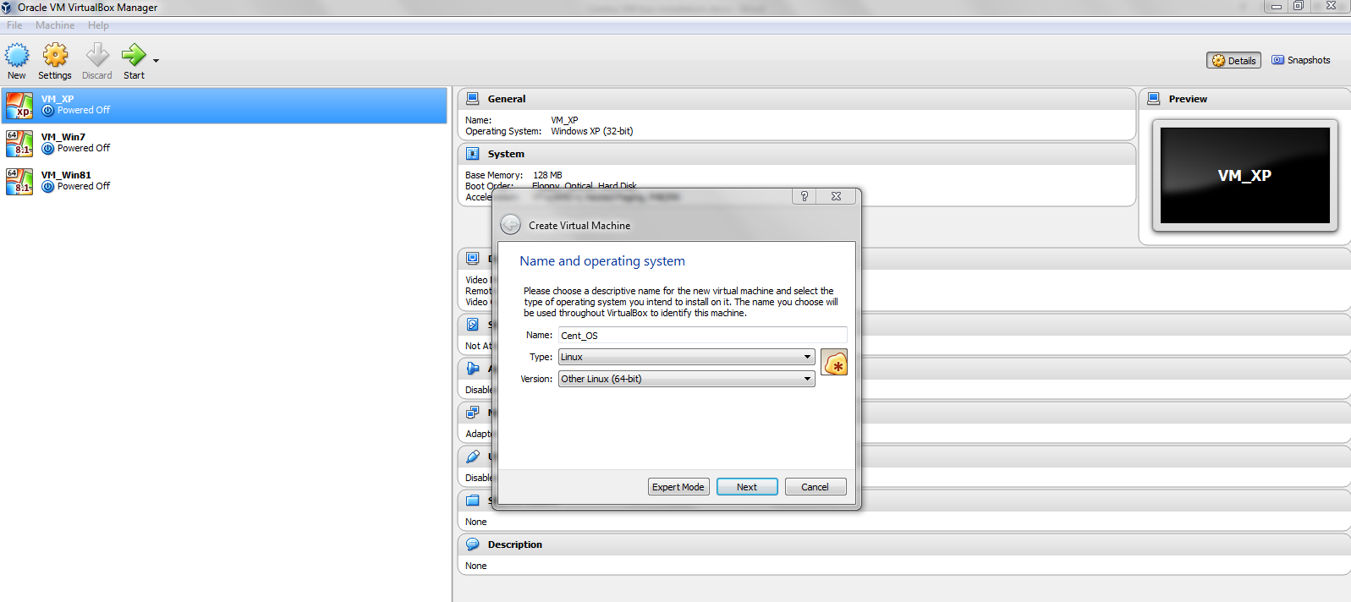

* Allocate the memory for that VM (e.g 2 GB)

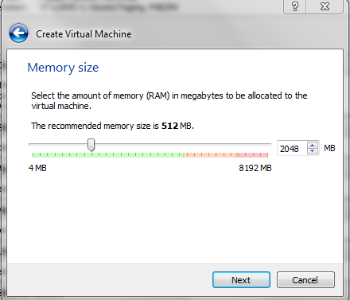

* Next Create a new Virtual Hard Disk. It will consumes some local space in your Hard disk.

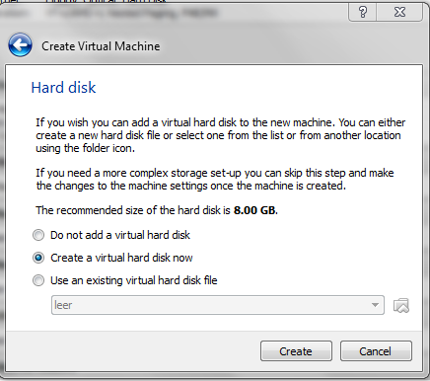

* Select VDI (Virtual Disk Image) in the list.

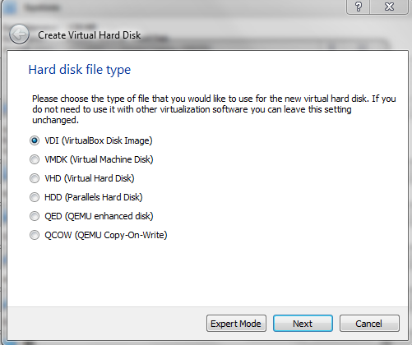

* Select Dynamically Allocated and then click next.
* In next dialogue box, leave the file name as default & enter the value of the memory size is 2 (i.e 2 GB) and then Click Create.

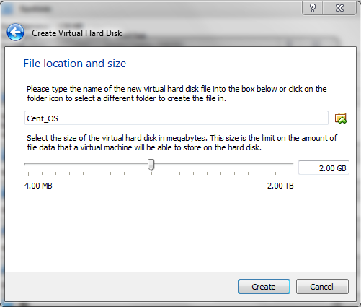

* Next we need to configure the system. For that please right click the created OS in the list items and click Settings
* In setting window, Click Storage load secondary image of your local ISO.

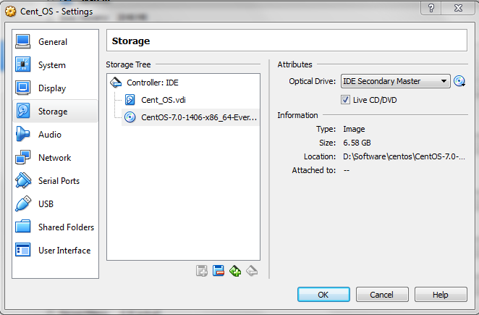

* For Network Settings, Click Network in setting menu. Enable NAT.
* And for Port Forwarding over SSH, Click Advanced option in NAT option

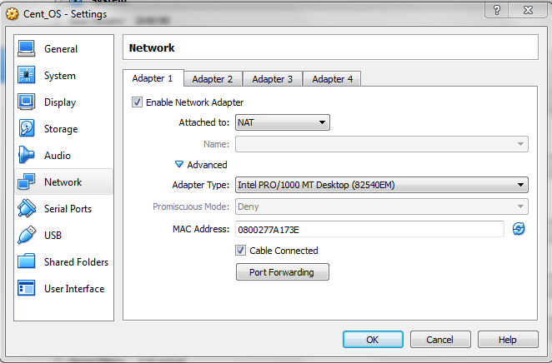

* Apply below configuration in that window

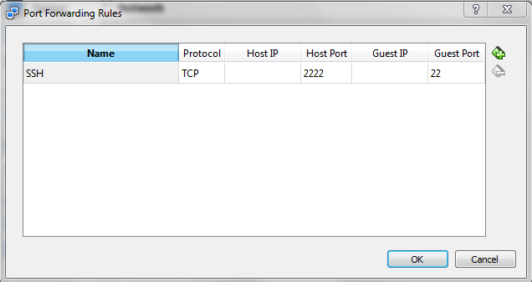

* For network Configuration, In Setting menu Click Network and then in Adapter tab select Bridge Network

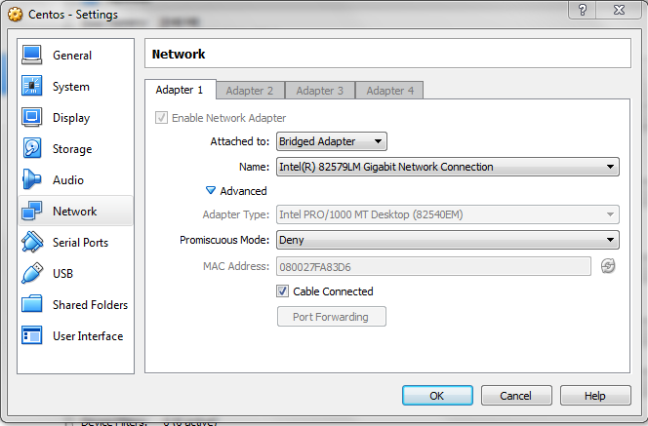

* Please make sure Promiscuous mode is deny in the Advanced option.